**Group Project Report: Design and Manufacture of Smart Elbow Brace**

**Feng Zhihan, Li Bingle, Li Xinyang, Sun Ziyue**

**Group 4-E**

|  |  |  |
| --- | --- | --- |
| Name | Report contribution | Sign |
| Feng Zhihan | **Project Manager and Documentation Specialist**  Documenting work, reviewing the literature and summarizing the information |  |
| Li Bingle | **Electronics Engineer & Software Engineer**  Designing process and circuit, connecting electronic components |  |
| Li Xinyang | **Test Engineer and Data Analyst**  Searching for information, testing and analysing data, making the slides and designing presentations, image recording |  |
| Sun Ziyue | **Prototyping Engineer**  Modeling, prototyping, testing data and assembling |  |



**Contents**

I.Introduction 1

II. Aim and Objectives 1

III. Background 1

IV. Materials and Methods 2

**A. Electronic components** 2

1. MPU6050 2

2. EMG sensor 2

3. MAX6675 2

4. Flexible heating pad and thermocouple 2

5. Electrical relay 2

6. Four-digit digital tube (LED) 2

**B. Programme** 3

**C. Manufacturing** 4

**V. Results** 5

A. Temperature monitoring and control 5

B. Exercise status monitoring 5

VI. Discussion 6

**A. Strengths** 6

**B. Limitation** **6**

VII. Conclusion 6

Reference List 6

Appendices 6

**Introduction**

The elbow joint is one of the important joints of the human upper limb, which plays a crucial role in the normal movement and contributes to the functions of the arm. However, when the elbow is injured or suffers from certain diseases, it can lead to pain, swelling and, if severe, movement disorders and other problems, which seriously affect daily life and work. In the prevention and treatment of elbow injury, the use of elbow brace is an important way. Firstly, it has a limiting and supporting role, which is able to limit the range of motion of the joint and avoid further damage, while providing appropriate pressure and support, which helps to reduce pain and swelling. Second, it has both remission and therapeutic effects. It can also help improve joint stability and function, promote muscle recovery and strengthening, and accelerate the rehabilitation process.

**Aim and Objectives**

The project aim of our group is to design and manufacture a smart elbow brace. This smart elbow brace can first achieve basic functions such as support cushioning and some recovery treatment. On this basis, we plan to add a real-time information monitoring system to better analyse the wearer's elbow joint and provide recommendations. At the same time, a temperature control module will be added to control the temperature of the brace to provide help for the prevention and treatment of elbow joint diseases and injuries.

To achieve this aim, we need to use engineering design process. After identifying the need and gaining information about this, the solutions can be got by making mind map and brainstorming. Several sensors are used in our device, including an angle sensor which can measure the elbow movement angle in real time, an electromyography (EMG) sensor which can monitor the electromyography signal when the elbow movement occurs, and a temperature control module which can measure the elbow temperature and adjust the temperature automatically.

Then a prototype based on our solutions is needed to be constructed to make our device in reality. At first, we built a 3D model including the position of each part as a reference. After this step, our smart device can be made on the basis of the common brace. Those functions need to be combined and concentrated on the brace to improve practicability and wearability on the premise of achieving the functions of each part at the same time. Through verification test and validation test, our device is proved that it not only meets the specifications, but also fulfils the purpose.

**Background**

The elbow joint scaffolds can be divided into protective scaffolds and mobilization scaffolds, and we focus on the former, which is designed for preventing injury, protecting the injury site and performing conservative treatment [1]. Due to the limitation of the existing materials, the sleeve brace we designed can better meet the requirements of our problem, which also makes the design and manufacture of the device more feasible.

According to our investigation, the main causes of elbow joint diseases and injuries are: (1) improper posture or angle of elbow joint activity, resulting in joint wear or muscle strain; (2) overuse and high frequency use of elbow joint resulting in injury; (3) insufficient muscle strength and stability leading to elbow joint stress and injury [2].

To solve the first and the second problem mentioned above, a timely information monitoring and feedback function is needed, which can reduce the possibility of injury to the wearer without knowing the status of the elbow. The practice of continuous monitoring of human joint movement in a long term has many applications in the medical and rehabilitation fields [3], so the feasibility of this method has been proved. For the third problem, the basic functions of the elbow brace like support and fixation are also necessary.

According to our investigation on the market, at present, the widely-used common elbow brace still has some limitations, such as inability to feedback information, making the motion information cannot be monitored by the wearer in real time, and inability to adjust the function according to the actual situation. It relies on professional guidance that is not ongoing, has no interaction function with the wearer, and is only an independent medical device. Although these common elbow braces can meet the basic function of the brace, there are still shortcomings in the prevention of elbow joint injury and the monitoring of its health status.

**Materials and Methods**

**·Electronic components**

(1) MPU6050

The raw data of acceleration and Angle were read by MPU6050, and the data management platform (DMP) converted the raw angular velocity into quaternions to complete the calculation of Euler Angle. It can monitor the information of elbow stretching angle and motion state in real time, and summarize the information to the receiver for real-time feedback to the brace wearer. This makes the smart brace more transparent to the wearer about the movement of the elbow joint, allowing the wearer move the elbow more properly and avoiding causing injury. At the same time, the real-time information feedback makes the prevention of elbow injuries timelier, avoiding the problem of only getting feedback from the hospital without wearing this smart brace.

(2) EMG sensor

Two surface electrodes of EMG sensor are placed on biceps, and another surface electrode is placed on the skin surface of the wrist. When the monitored muscle is active, the EMG signal is received by electrodes placed on the muscle surface, and after amplification processing, the real-time EMG signal is displayed in the form of an image. Relying on the EMG sensor which is built-in, the smart brace can evaluate the frequency of movement of the wearer's elbow, provide recommendations according to the health status of the wearer's elbow joint, and control the frequency of movement to alleviate injury or muscle rehabilitation.

(3) MAX6675

The MAX6675 is a precision thermocouple digital converter with a built-in 12-bit analog-to-digital converter (ADC) designed for use with external microcontrollers or other smart devices in thermostatic, process control or monitoring applications. In our device, the MAX6675 and thermocouple are used together (Picture 1) to detect and correct the ambient temperature changes by cold end compensation, which allows it to accurately measure, calculate and output the temperature at the hot end in real time.

(4) Flexible heating pad and thermocouple

A problem we notice is that decreased environment temperature is associated with increased joint pain and stiffness [4], so when the winter or cold weather comes, it will be detrimental to elbow joints. For this temperature problem, a heating pad is supposed to control the temperature of the smart elbow brace. If the temperature detected by the thermocouple is too low, the heating piece will be heated automatically, and the temperature upper limit will be set to avoid low temperature scald caused by too long heating time. In order to fit the brace and the wearer's skin, flexible heating pads were used instead of rigid heating pads.

(5) Electrical relay

An electrical control device, is when the input changes to meet the specified requirements, in the electrical output circuit to make the controlled quantity of a predetermined step change of an electrical appliance. Relay has control system and controlled system, usually used in the automatic control circuit, in the circuit plays an automatic regulation, safety protection, conversion circuit and other functions. In our device, a relay is connected to the circuit of the temperature control module, and it controls the operation of the module on and off.

(6) Four-digit digital tube (LED)

We use a four-digit digital tube for clock communication to display the temperature in real time. The four-digit digital tube for clock communication requires only four pins, namely the VCC supply pin, the GND ground pin, the SCK clock pin, and the DIO digital output and input pins. Compared with the common cathode or common anode four-digit digital tube, the four-digit digital tube for clock communication greatly reduces the consumption of the pin. The clock is an oscillating signal that tells the receiver to sample the signal on the data line at the exact time. The LED we use transmits data on the rising edge of the clock signal, and each rising edge of the clock controls the on-off of individual slices on the LED screen. Because the frequency of the switch is high enough, the human eye does not see the flickering of the slice.

**·Programme**

(1) Multithreading

We use the Scoop library to implement multithreading on the Arduino, which enables multiple functions to be performed simultaneously. We have divided into three threads by function. The first thread is to measure and display temperature, the second thread is to monitor muscle potential and calculate muscle contraction time using EMG sensors, and the third thread is to monitor the lateral rotation angle of the arm through the MPU6675 module. By using multithreading, these three functions work separately and do not interfere with each other. When one of the threads stops the program using the sleep() function (which has similar functionality to the delay() function), the other threads are not affected. The use of multi-threading greatly improves the sensitivity and accuracy of temperature measurement, improves the accuracy of angle monitoring, and realizes the function of calculating muscle contraction time.

(2) Temperature control and display

We use the MAX6675 library to process the data obtained under the SPI communication protocol to obtain accurate temperatures. The thermocouple.readCelsius() function can get the exact temperature and get a floating-point number. We multiply the resulting floating-point number by 100 to get a four-digit integer and convert the four-digit integer into a character array with five elements (including a decimal point). Then use the functions in the tm1650 library to output the character array to the LED. For the resulting temperature floating-point number, we store it in a variable and judge the variable. When the value of the variable, that is, the temperature is greater than 45, a low level is output to the signal pin of the relay, so that the heating circuit is disconnected. When the value of the variable is below 45, a high level is output to the signal pin of the relay, closing the heating circuit.

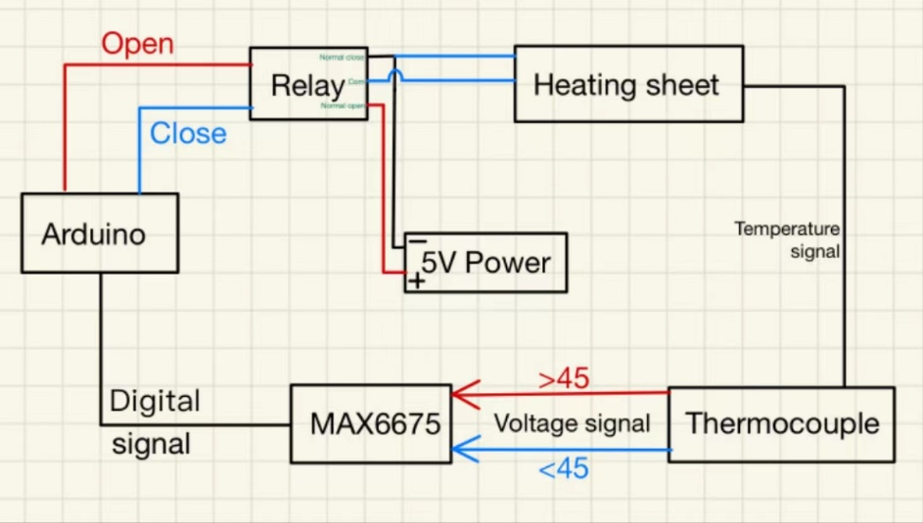

*Picture 1 - Schematic diagram of temperature control system*

(3) Muscle condition monitoring

We use the analogread() function to read six different values returned by the EMG sensor and save them in an array. We have done a lot of testing to get the different components of this set of numbers in two different states: muscle contraction and relaxation. We use two while loops for timing and reminders. The condition for the first while cycle is that the muscle is contracted and the time is less than 5 seconds (convenient for testing only). After the muscle contracts for more than 5 seconds, a second while cycle begins. The condition of the second while cycle is that the muscle is contracted. As long as the muscles remain contracted, the buzzer will sound an alarm and send a "release" reminder to the mobile phone through the Bluetooth serial communication interface.

(4) Lateral rotation angle monitoring and feedback

Since the MPU6650 module uses the IIC module, we use the Wire library to obtain the data of the MPU6650 module. When the IIC bus transmits data, the data on the data line must remain stable during the period when the clock signal is high, and only during the clock level is low, the high level or low state on the data line is allowed to change. That is, the data needs to be ready before the rising edge of the clock line SCL arrives, and must remain stable before the falling edge arrives. When the data line SDA and the clock line of the IIC bus are high at the same time, it is specified as the idle state of the bus. At this point, the FET at the output stage of each device is in the cut-off state, that is, the bus is released, and the level is pulled high by the pull-up resistors of the two signal lines. During the period when SCL is high, the change of SDA signal line from high level to low level indicates the starting signal; During the period when SCL is high, the change of SDA from low to high indicates the termination signal. SDA: High to Low – Start signal SDA: Low to High – End signal. Both the start signal and the stop signal are sent by the host, and after the start signal is generated, the bus is in the occupied state, and after the stop signal is generated, the bus is idle [5].

We use the Kalman filter library to filter the acquired acceleration data to ensure the stability and reliability of the data. As long as there is a dynamic system with uncertain information, the Kalman filter can make educated guesses about what the system will do next. Even with noise information interference, Kalman filtering is usually a good way to figure out what is happening and find subtle correlations between phenomena. This makes Kalman filtering ideal for changing systems, with advantages such as a small memory footprint (only the previous state remains), and high speed, making it ideal for real-time problems and embedded systems.

We judge the obtained pitch value through the if judgment statement, and when the pitch value is greater than 10 (indicating that the angle of rotation is too large), the buzzer issues an alarm, and sends a "danger" alarm to the mobile phone through Bluetooth serial communication.

(5) Macros define pins

We use macro definition to define the pins of different sensors and different modules, which greatly facilitates our testing. Different team members can quickly and accurately know the corresponding pin when they see the name of each pin. When moving and replacing pins, we only need to change a single number.

**·Manufacturing**

In the actual production process, due to the limitation of realistic conditions, we adopted the idea of integration in the installation of some modules, and stacked multiple smaller electronic components together to save the volume of the equipment as much as possible. In the process of determining the installation position of each component, we tested the range of motion of the elbow in various situations, and avoided the problem of affecting the normal movement of the elbow due to the obstruction of the device.

In order to increase the readability of monitoring data and the wearer's experience, we connected the smart elbow brace with the receiver software on the phone by Bluetooth, so that the wearer could easily get information about the elbow and get advice.

**Results**

After testing, all parts of the smart elbow brace were able to achieve their intended functions. The test results are shown below (Picture 2).

**·Temperature monitoring and control**

The temperature is successfully measured by the thermocouple in real time, and the temperature is displayed on a small LED screen that comes with the brace. When the temperature is below 45 degrees Celsius, the relay will be connected, making the heating sheet work. When the temperature goes above 45 degrees Celsius, the relay will be disconnected and stopping heating.

**·Exercise status monitoring**

EMG sensors is able to monitor the contraction and relaxation status of the biceps muscle, and the buzzer sounds an alarm when it contracts for too long. For testing convenience, we set the time to 5 seconds. When the muscle contracts for more than 10 seconds, the prompt information "release" is displayed on the phone. At the same time, an alarm will be produced by the buzzer.

The function of monitoring angles is also available. When the arm rotates sideways beyond a certain angle, the buzzer sounds an alarm and the prompt information "danger" appears.

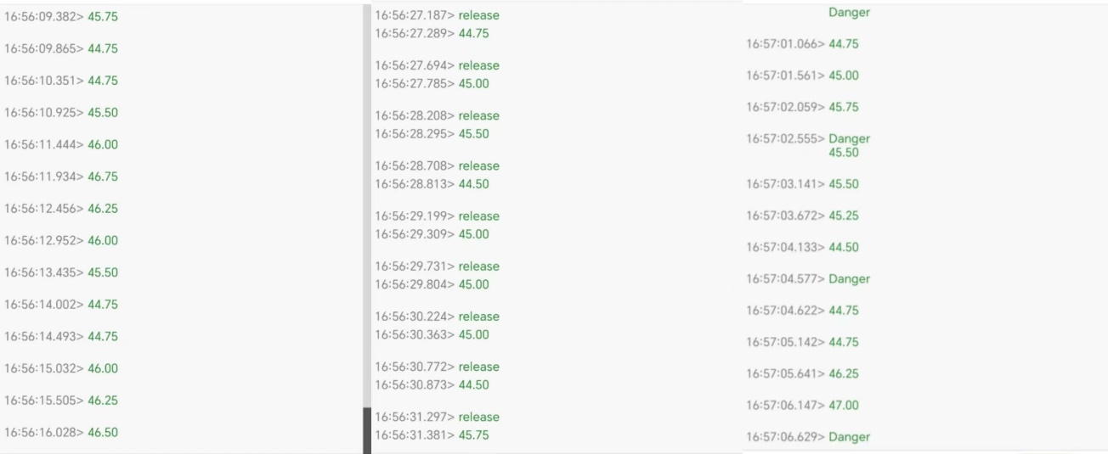

*Picture 2 - Receive real-time data and alerts on the phone*

**Discussion**

**·Strengths**

The reliability of the measured data is one of the strengths. The thermocouple can normally measure a wide range of temperatures and can completely cover all temperatures of the daily living environment, which ensures that it will not change its working state due to environmental changes. At the same time, it is an accurate sensor that can measure small temperature changes to two decimal places, continuously monitoring and sending information at very short time intervals, so that real-time temperature changes can be continuously obtained. The directly used medical electromyography sensor also has high precision and is very sensitive. Through the analysis of electromyography in multiple tests, the data obtained are within a reasonable range, which proves that the measurement method and data acquisition process are correct and accurate.

**·Limitations**

One limitation is that there may be differences in muscle status and elbow health among different wearers. For example, different wearers may have different angles at which their elbows can move normally and different areas of their elbow muscles that are suitable for monitoring. When using sensors for monitoring, the set standard control value may not be suitable for all cases, causing the problem of inaccurate results. Another limitation is that with the current design, most of the electronic components are exposed outside the brace, the data may be affected by environmental factors, and there is no enclosure to protect the external components to ensure that they continue to work properly.

Besides, the durability of the equipment is still lacking. At present, the battery we carry has a short service life. Once it runs out of power, it needs to be replaced, which is not convenient enough. In terms of circuit design, there are some areas that can be improved. The voltage supplied to EMG sensor is insufficient, which can be improved by adding transformer. The electric power supplied to the heating sheet is insufficient, and the method of replacing the power supply and using the lithium battery can be adopted.

**Conclusion**

We successfully manage to develop a smart elbow brace which is able to meet all our requirements and constraints. For the objectives, we follow all the steps of the design process. We design a prototype and manufacture our device based on the draft. Through repeated test, the scientific nature of the research and development process can be ensured.

For our project aims, our device was able to stably perform its intended function. First, all the sensors are in function, enabling the device to monitor the motion state and temperature of the elbow joint. Second, the device has information transmission and interaction functions. The data collected in real time are pooled and analysed, and their values and prompt messages were sent to the phone receiver and are accessible to the wearer.

In the future, the possible improvement directions of this device are: (1) Reducing its size to improve the portability of the device; (2) Adding a case that can protect the electronic components to improve the durability of the device without affecting the normal activities of the wearer; (3) It can be connected to the Internet to obtain health advice or interact with medical staff at a distance to improve its intelligence.

**Reference List**

[1] A. Marinelli and R. Rotini, “Brace and Rehabilitation,” *The Elbow*, pp. 577–588, Jul. 2017, doi: https://doi.org/10.1007/978-3-319-27805-6_43.

[2] K. M. Lin, T. S. Ellenbecker, and M. R. Safran, “Rehabilitation and return to sport following elbow injuries,” *Arthroscopy, Sports Medicine, and Rehabilitation*, vol. 4, no. 3, Mar. 2022, doi: <https://doi.org/10.1016/j.asmr.2022.01.012>.

[3] P. T. Gibbs and H. H. Asada, “Wearable Conductive Fiber Sensors for Multi-Axis Human Joint Angle Measurements”, *Journal of NeuroEngineering and Rehabilitation*, vol. 2, no. 1, p. 7, 2005, doi: https://doi.org/10.1186/1743-0003-2-7.

[4] H. Aikman, “The association between arthritis and the weather,” *International Journal of Biometeorology*, vol. 40, no. 4, pp. 192–199, Jun. 1997, doi: <https://doi.org/10.1007/s004840050041>.

[5] “Summary of IIC communication protocols”, blog.csdn.net. https://blog.csdn.net/m0_37573557/article/details/121401455 (accessed Jul. 20, 2023).

**Appendices**

|  |  |  |  |
| --- | --- | --- | --- |
| Name | Test 1 | Test 2 | Test 3 |
| EMG | 4965c7d20895481e77ec6664f8dbfc4c673e0cb191594d11688a04c163343c | 37615af5e851207a6fc2426cd72718ac673e0cb191594d11688a04c163343c | f46ed3b747f8c5f54721e92acfe771560545fd01727bde85bb407fb8bdb6d1 |
| Angle sensor | Pitch axis  From -15°to 15°  The mast accurate | Roller axis  From -15°to 15°  Comparatively accurate | Z axis  From -15°to 15°  Most inaccurate |
| Temperature sensor  and the flexible heating element | The system keep in 45℃  It can keep the elbow warm and protect the elbow. | The system keep in 50℃  It will be overheated and harm to skin. | The system keep in 40℃  It can’t protect the elbow |